# Web Components - Workshop

Problems for exercises and homework for the ["JavaScript Applications" course @ SoftUni.](https://softuni.bg/trainings/4228/js-applications-october-2023)  
The following tasks do not have tests in the Judge system. They are for practice.

## Custom Buttons

Create a custom button web component that accepts a **text** and **type** as attributes. The **type** is a **class**, which should be **primary**, **accent** or **warn:**



## Popup Widget

Create a custom popup widget that accepts **popup text**, **source image** and **alternative image**. The text appears when the icon is **hovered**:

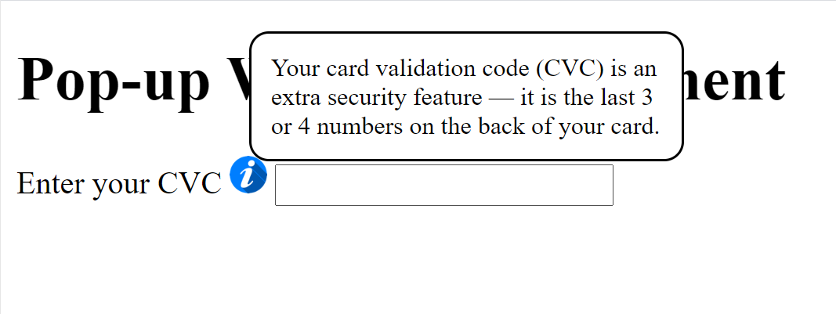

## User Cards

Create reusable user cards. Each receives **name**, **avatar**, **email** and **phone** (add the email and phone using **named slots**). The info should be **toggleable:**

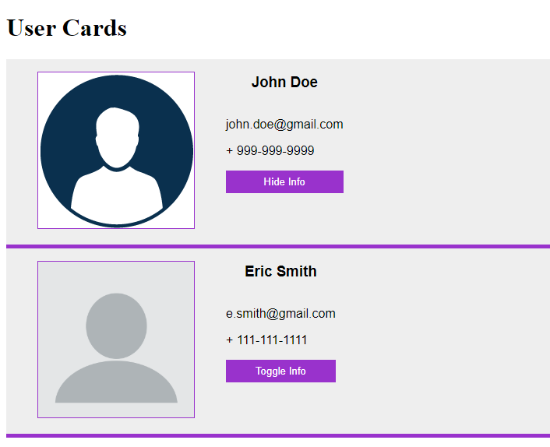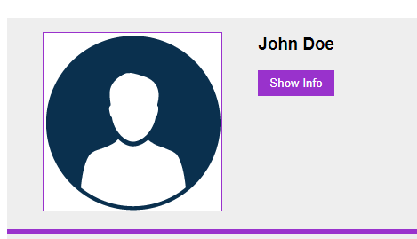

## Expanding List

Extend the functionality of an **unordered list** so it expands all the **list items inside**. The list should be able to **shrink** itself as well.

Demonstration [here](https://ibb.co/f2d5cmq)

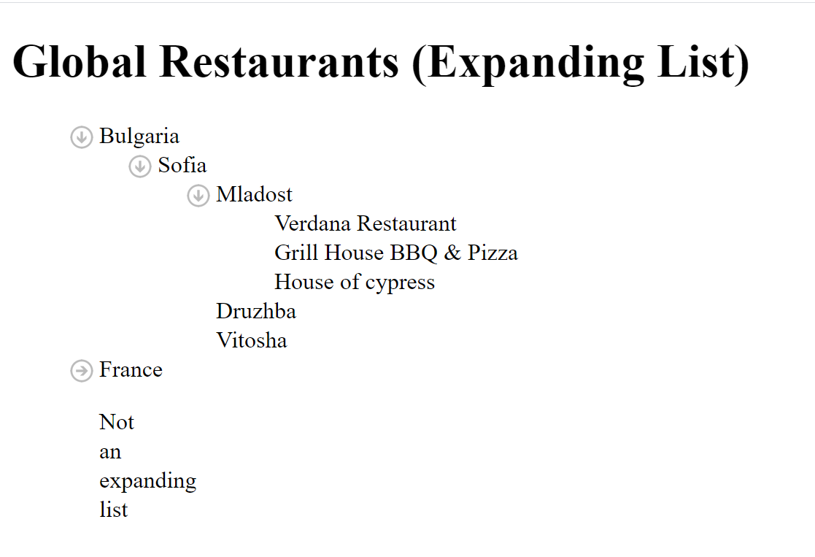

## Slider

Create a slide component, which could accept an **initial value** of the input and a **step** to increase it with. The slider should also calculate the **percentage** it is **full**. Optionally make it so that if **"inverted"** is passed as an **attribute**, the slider starts from **right** to **left**.

Normal demonstration [here](https://ibb.co/LNngPHf)

Inverted demonstration [here](https://ibb.co/fqxNr9f)

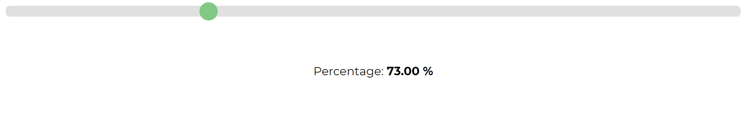

## Editable List

Create an editable list component that accepts a **main title**, an **initial amount** of list items and a **title** for the **input** below as **attributes**. The list should have the functionality to **add** and remove **items**. You **should not** be able to add an **empty** element.

Demonstration [here](https://ibb.co/gvVDdPH)

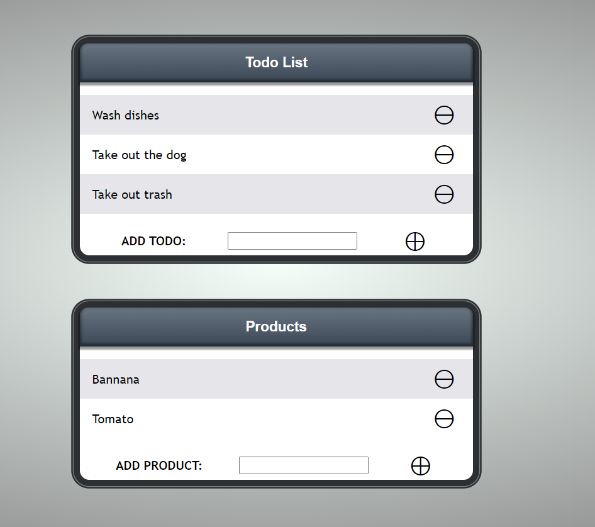

## Carousel

Create a slideshow carousel component that accepts **image URL's** and for each image there is a **caption** below as **attributes**. Each slideshow item should hold **image URL**, **caption text** and a **counter on the top left**.

Implement functionality to **switch between images**, by using the **left** and **right arrows**. If there **is not** another **right** element, start from the **beginning**. If there **is not** another **left** element start from the **end**. Below the carousel there should be **N number** of **dots** (**N** being the **passed in images**) that when **clicked** should select an image **directly**.

Demonstration [here](https://ibb.co/k95scrc)

